Husky Air Project Report
Team A: Muhammad Umar, Ali Al Kindi, Ragheeb Clarke & Mohammed Albaqami
Project Management IT
Florida Institute of Technology

Table of Contents
Executive Summary…………………………………………………………………………………..3
Team Charter……………………………………………………………………………………………..
Learning Cycle/Action Record…………………………………………………………………….
Business Case & MOV Statement……………………………………………………………….
WBS, Schedule & Budget……………………………………………………………………………….
Use Case & Deliverable Structure Chart……………………………………………………..
Risk Management Matrix…………………………………………………………………………...
Earned Value Analysis………………………………………………………………………………...
Lessons Learned………………………………………………………………………………………….
Reference Page…………………………………………………………………………………………...

TEAM CHARTER

Team Norms
1. Punctuality – Each team member will try their best to show up for meetings/class on time.
2. Workload – Each team member will do an equal amount of work and will do their best to have it in on time.
a. Participating and Providing ideas for the project
b. Complete assigned tasks on time
3. Communication - Each team member will have an opportunity to share their thoughts/opinion, and
a. Proper communication between each other if a member cannot attend class/meeting.
b. Actively listening to show team members respect.
c. Giving feedback on ideas

4. Meeting Times – Everyone will be responsible to attending meetings and at the meetings, each member promises to focus and pay attention.
5. No Phones policy
6. Attitude - Positivity is key!

Meeting Place: OAK 145 – College of Business
Time: Monday & Wednesday 12: – 1:45pm

Executive Summary

Learning Record

Fact | Assumption | Questions to be Answered
The company wants to have a system to keep track of volunteer records | They don't have any current system installed. All are paper work | What kind of information system they need?
The company needs to have a new way of inputting data | They don't have the information saved | How do they want to input the data?
The company wants to know more about the people, hospitals, clinics, and organ banks that request their service | they never collected any data for these | How will we get these data?
The company wants a list of all Pilot Angels flights in order to pay recognition to volunteers and their contributions. | they have criterias to define which pilots contributed more | is it by distance, number of flight, or total hours spent for the cause?

ACTION PLAN

Who? | Does What? | By When?
Muhammad | Find the best type of system that would suit the company | Wednesday
Ali | Figure out the best way of inputting information into new system | Wednesday
Mohammed | Make a survey to get the data from organizations that need their services | Wednesday
Ragheeb | Compile a full list of pilot angels | Wednesday

MOV Statement:

Track and reduce the costs of organizations and people that request the Husky Air Service by an accuracy of 80% by 17th of January 2018.

Business Case:
1- Keep the current paper file records
Keeping the current paper tracking system would result in low accuracy when inputting and locating data. Identifying which pilot put in more effort will be more difficult due to the use of this system. The system will also require a physical storage and more experienced personnel to handle it and in turn, they will require considerably higher wages. Furthermore, the system will most likely not be able to keep up with the expansion of the company in the upcoming years.
2- Purchase an existing system
Purchasing an existing system will provide the company with a system that is able to enter and retrieve data in real time as well as exchanging them with pilots and hospitals. The system will only require a PC to handle the information and a server, in case of expansion. The system would incur initial costs for training, maintenance and an IT specialist but it would save a lot of time and money for the company in the long-term because it would require less working hours by employees.
3- Develop their own system
Developing a new system would provide similar traits as buying an existing system but it would provide more advantages. An off the shelf system could provide some of the requirements necessary but could possibly miss some essential properties. Making a new system will have different costs as purchasing an existing system due to the fact that you would hire programmers to develop it. Developing a new system would cost more than purchasing an existing system, but the functions of the system will be guaranteed to align with the vision of company.

Alternatives | Annual Salary | System development cost | Hardware cost | Training cost | Total
Paper based | 30000$ | - | - | - | 30000$
Buy a package | 21000$ | 460$ | 600$ | 300$ | 22360$
Create a custom system | 14000$ | 7860$ | 600$ | 300$ | 22760$

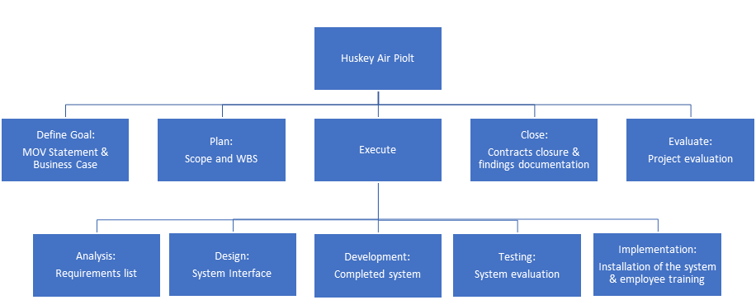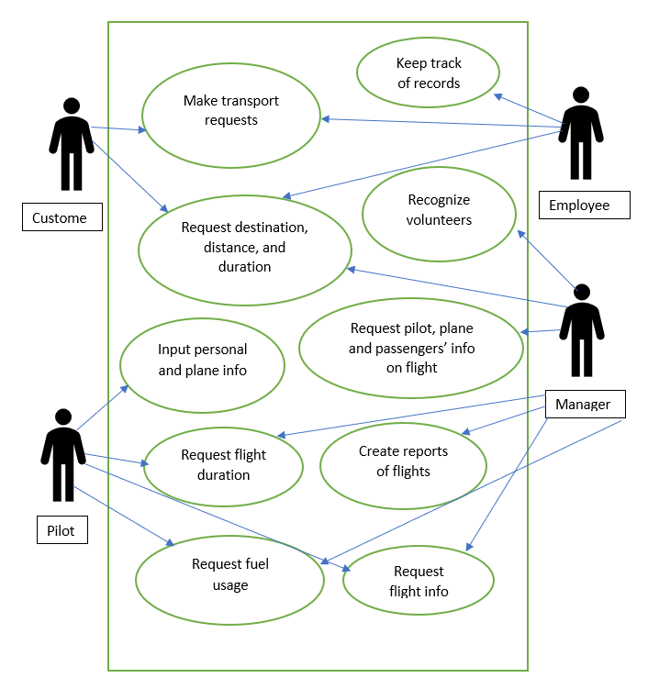

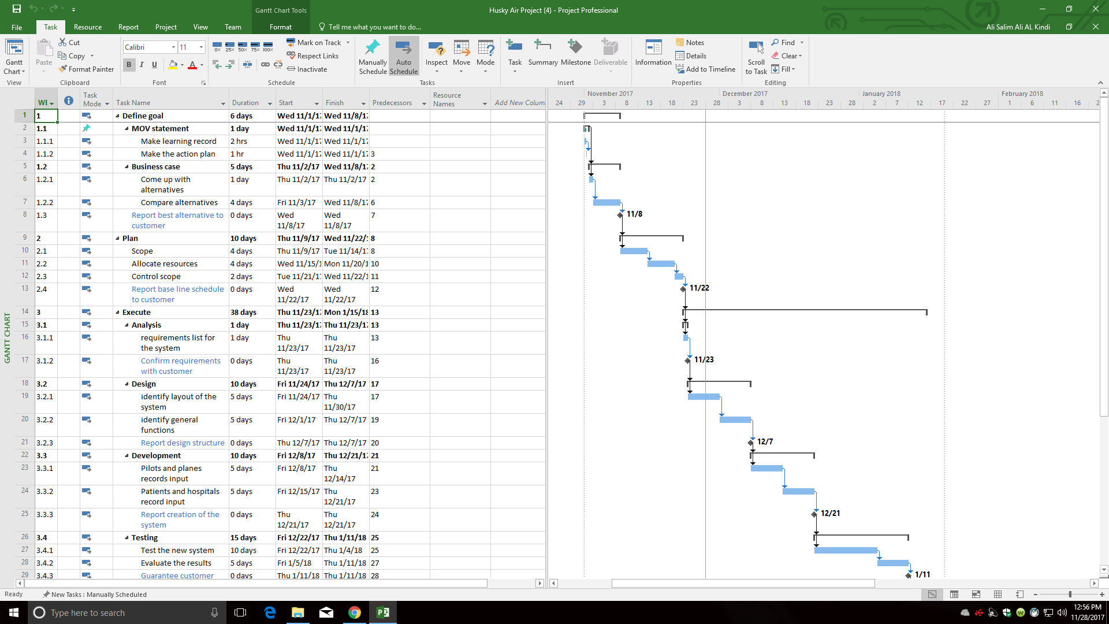
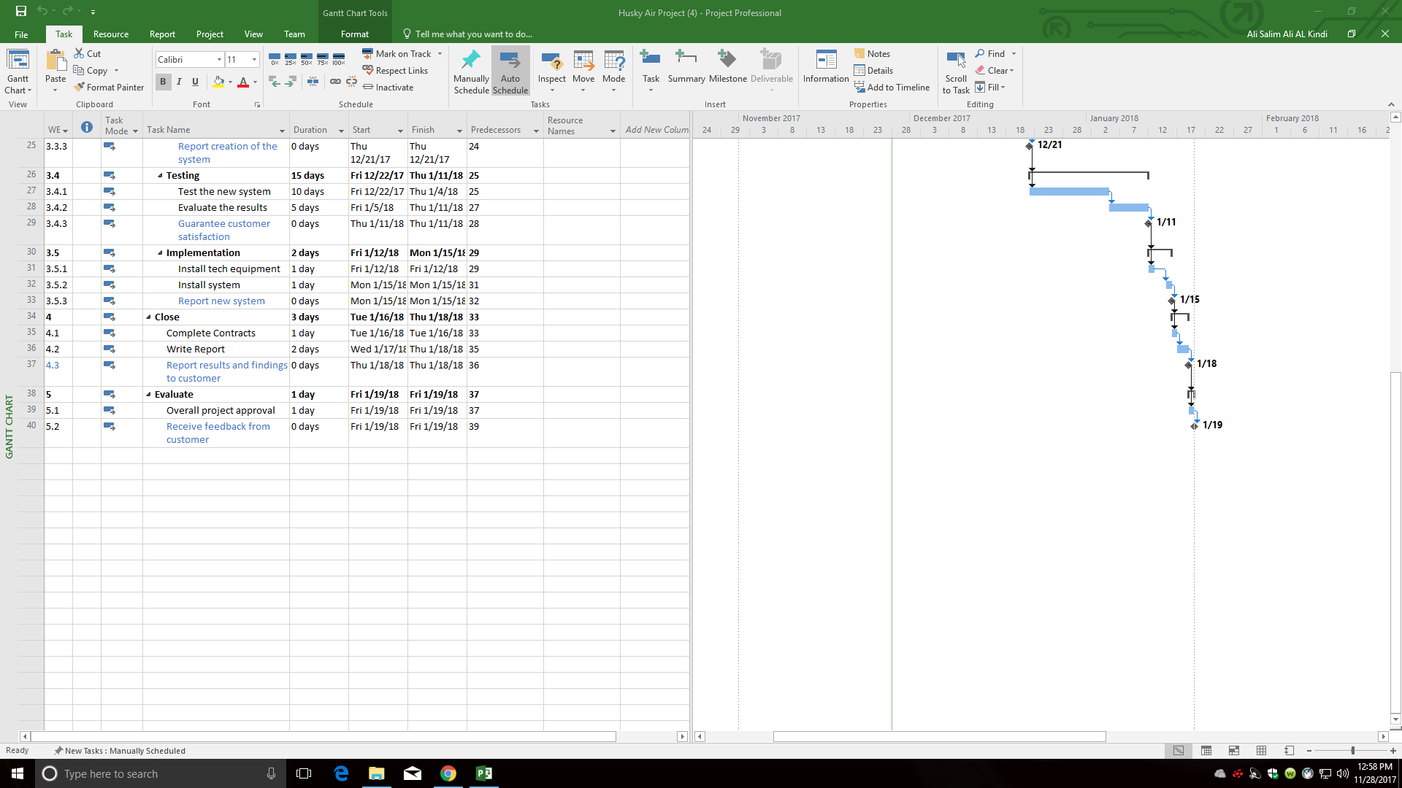

Risk | Consequence | Probability (L,M,H) | Severity (L,M,H) | Action Trigger | Responsibility | Response Plan
Team member leaving | Delay the project | L | H | Fail to meet team norms | Ali | Have replacements ready
Disapproval of the system | Delay the project | L | M | Expensive | Ragheeb | Have other option ready
Wrong data validation method | Delay the project  Exceed budget | L | L | Incorrect data entry | Muhammed | Review data
Failure to accept the new system | Modify the system | M | H | Difficulty to use the system | Ragheeb | Develop a user guide
Fail to negotiate price with software development team | Exceed budget | H | H | Huge variance in in the base pay for software engineers | Mohammed | Have back up funds in reserve
Inaccurate estimates for prices | Exceed budget | L | M | Prices of electronics vary with time | Ali | Have back up funds in reserve
Inaccurate estimates for schedule | Delay the project | M | H | tasks may take longer to be complete | Muhammed | Increase number of working hours per day
Lack of technical skills | Delay the project | M | H | No training was conducted to ensure system compliance | Ali | Ensure to have a training team stand by
Delay of completing/ delivering the system | Delay the project | M | H | The duration of the system design phase took more time. | Mohammed | Increase number of working hours per day

Task | Month 1 | Month 2 | Month 3
MOV Statement | 90$
Business Case | 450$
Planning | 900$
Analysis | 260$
Design | 830$ | 830$
Development |  | 1660$
Testing |  | 900$ | 990$
Implementation |  |  | 560$
Close |  |  | 270$
Evaluate |  |  | 120$
Total | 2530$ | 3390$ | 1940$

Project manager 30$/hr
System Engineer 40$/hr
MOV Statement – 3 Hours
Business Case – 3 hours/ 5 Days
Planning – 3 hours/ 10 Days
Analysis – 5 Hours/ 1 Day (se) 2 Hours/ 1 Day (pm)
Design – 4 Hours/ 10 days (se) 1 Hour/2 days (pm)
Development – 4 Hours/ 10 days (se) 1 Hour/2 days (pm)
Testing – 3 Hours/ 15 Days (se) 3 Hours/ 3 Days (pm)
Implementation – 4 Hours/ 2 Days (se) 4 Hours/ 2 Days (pm)
Close – 3 Hours/ 3 Days (pm)
Evaluate – 4 Hours/ 1 Day (pm)
Earned Value Analysis:

Task | Planned Value | Actual Value | Earned Value | Cost Variance | Schedule Performance Index | Cost Performance Index
Learning record | 60$ | 60$ | 60$ | 0$ | 1.00 | 1.00
Action plan | 30$ | 30$ | 30$ | 0$ | 1.00 | 1.00
Come up with alternatives | 90$ | 90$ | 90$ | 0$ | 1.00 | 1.00
Compare alternatives | 360$ | 360$ | 360$ | 0$ | 1.00 | 1.00
Create scope | 360$ | 360$ | 360$ | 0$ | 1.00 | 1.00
Allocate resources | 360$ | 360$ | 360$ | 0$ | 1.00 | 1.00
Control scope | 60$ | 60$ | 60$ | 0$ | 1.00 | 1.00

Lessons learned:
As a team:

Individually:
Ali:
Ragheeb:
Mohammed:
Muhammed:

